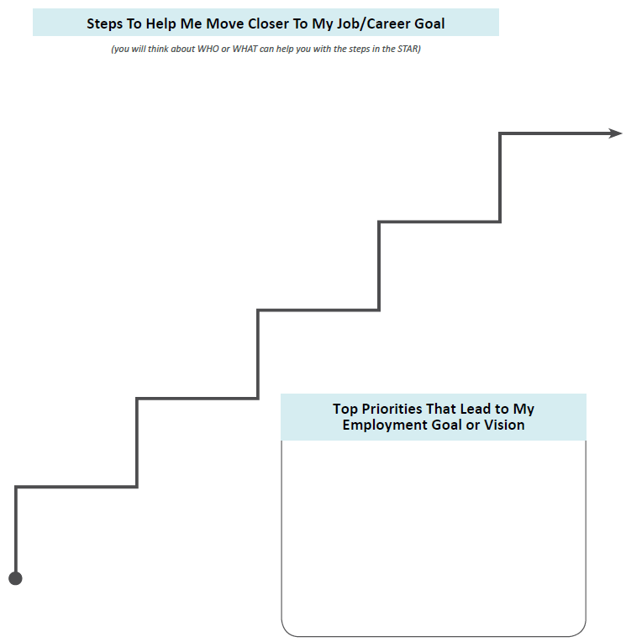

**What is my short-term goal for employment? Long-term goal for employment?**

**What experiences do I need to have in order to identify my goals?** Career exploration, job shadow, volunteering,

**What are the things I must have to apply for or accept a job?** Resume, work Identification documents, transportation

**Do I need additional training, education, license?**

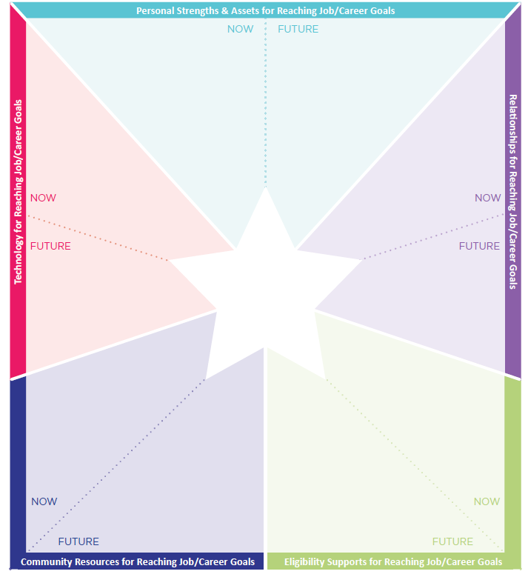

What have coworkers or supervisors appreciated about you? What about friends and family members?

Who is in your family circle? Friend circle? Community connections (store clerk, library, hobbies, sports, program attending/attended in past)? Current job? Past Jobs?

Do I have or am I eligible for state employment supports (DDS, MRC, DMH, other)? CBDS or other support services?

What tools, technology, supports do I use in my life right now that help me to work/participate in activities more independently?